# DATABASE SYSTEMS

# Hassaan Akbar Cheema

# Reg no. 174351

# Bscs6c

# Lab 09

**Task: Write correlated Nested SQL expressions for each of the following queries and execute them:**

1. Find the names of all juniors (Level = JR) who are either enrolled or not in a class taught by ‘Ivana Teach’.

select distinct s.sname from student s

join enrolled e on s.snum = e.snum

left outer join class c on c.cname = e.cname

left outer join faculty f on f.fid = c.fid and f.fname like 'Ivana teach'

where level like 'jr'

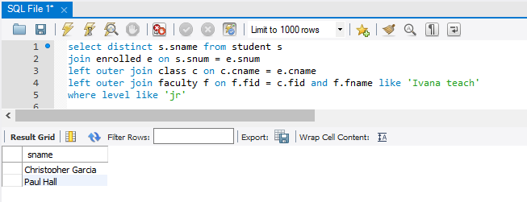

1. Find the names of faculty members that either teach to class ‘database systems’ or not.

select f.fname,c.cname

from faculty f

left outer join class c on c.fid = f.fid and cname like 'database systems'

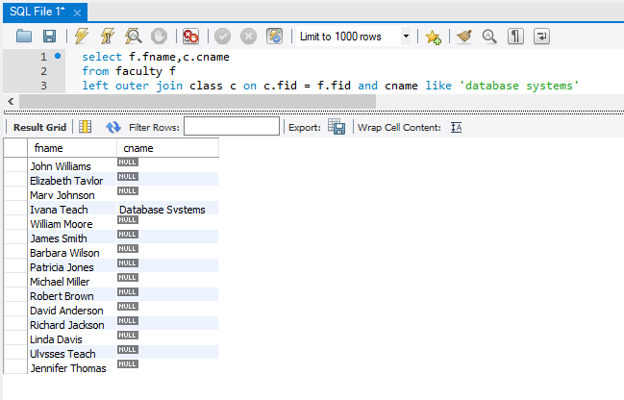

1. Find the name of the courses that is either taught by a faculty member or not.

select c.cname as Course_Name

from faculty f

left outer join class c on f.fid = c.fid;

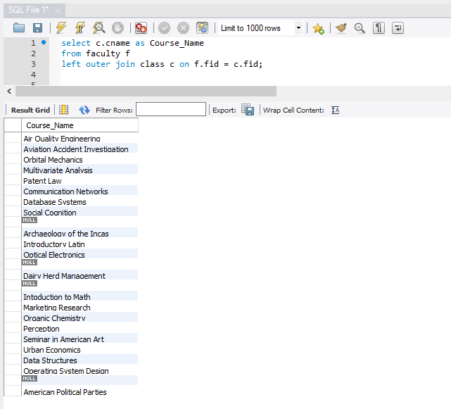

1. Find the names of classes that is either taught by ‘Richard Jackson’ or not and their times when a class meet there.

select cname,meets_at,fname

from class c

left outer join faculty f on c.fid=f.fid and fname = 'richard Jackson';

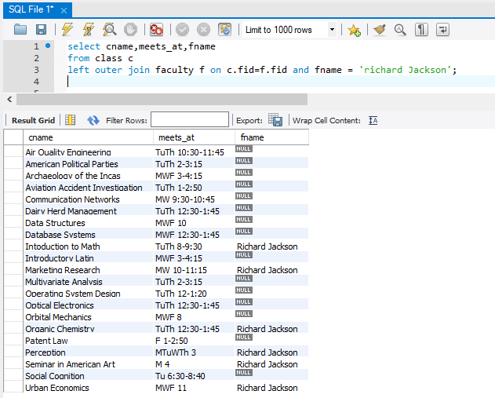

1. Retrieve the snum and sname of students who have taken classes either from ‘Ivana Teach’ or ‘Linda Davis’ or both.

select s.snum,s.sname,f.fname from student s

left outer join enrolled e on s.snum=e.snum

left outer join class c on c.cname=e.cname

left outer join faculty f on c.fid=f.fid

where f.fname='Ivana Teach'

union

select s.snum,s.sname,f.fname from student s

left outer join enrolled e on s.snum=e.snum

left outer join class c on c.cname=e.cname

left outer join faculty f on c.fid=f.fid where f.fname='Linda Davis';

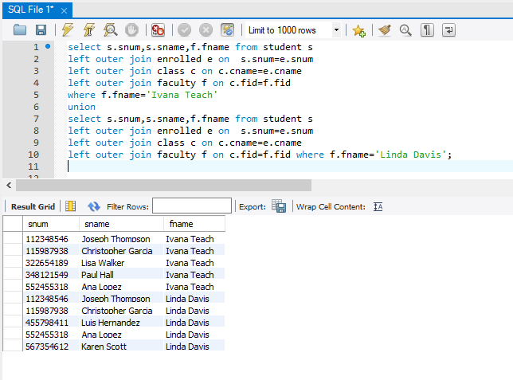

1. Find room number where a faculty member either takes a class or not.

select c.room,f.fname

from class c

left outer join faculty f on c.fid=f.fid;

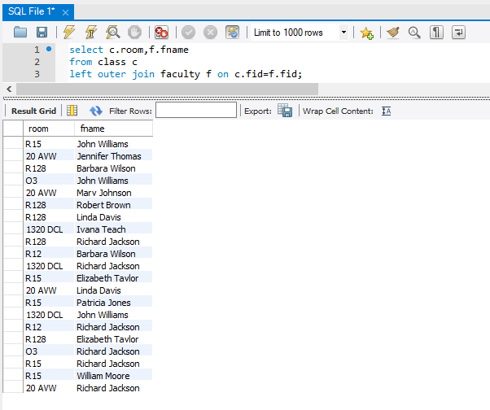

1. Find the department IDs where students have been enrolled or not.

select distinct f.deptid

from faculty f

left outer join class c using (fid)

left outer join enrolled e using (cname)

left outer join student s using (snum);

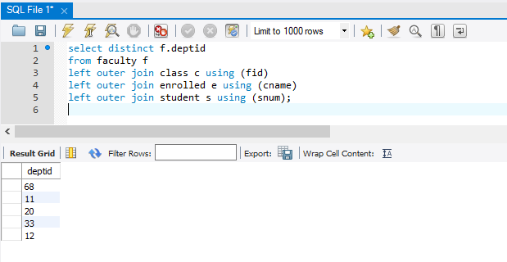

1. Find the room number where either Robert Brown teaches or not.

select distinct room,f.fname

from class c

left outer join faculty f on c.fid=f.fid and f.fname = 'Robert Brown';

